Lab 7

1. Staff Full Name, Job, Department

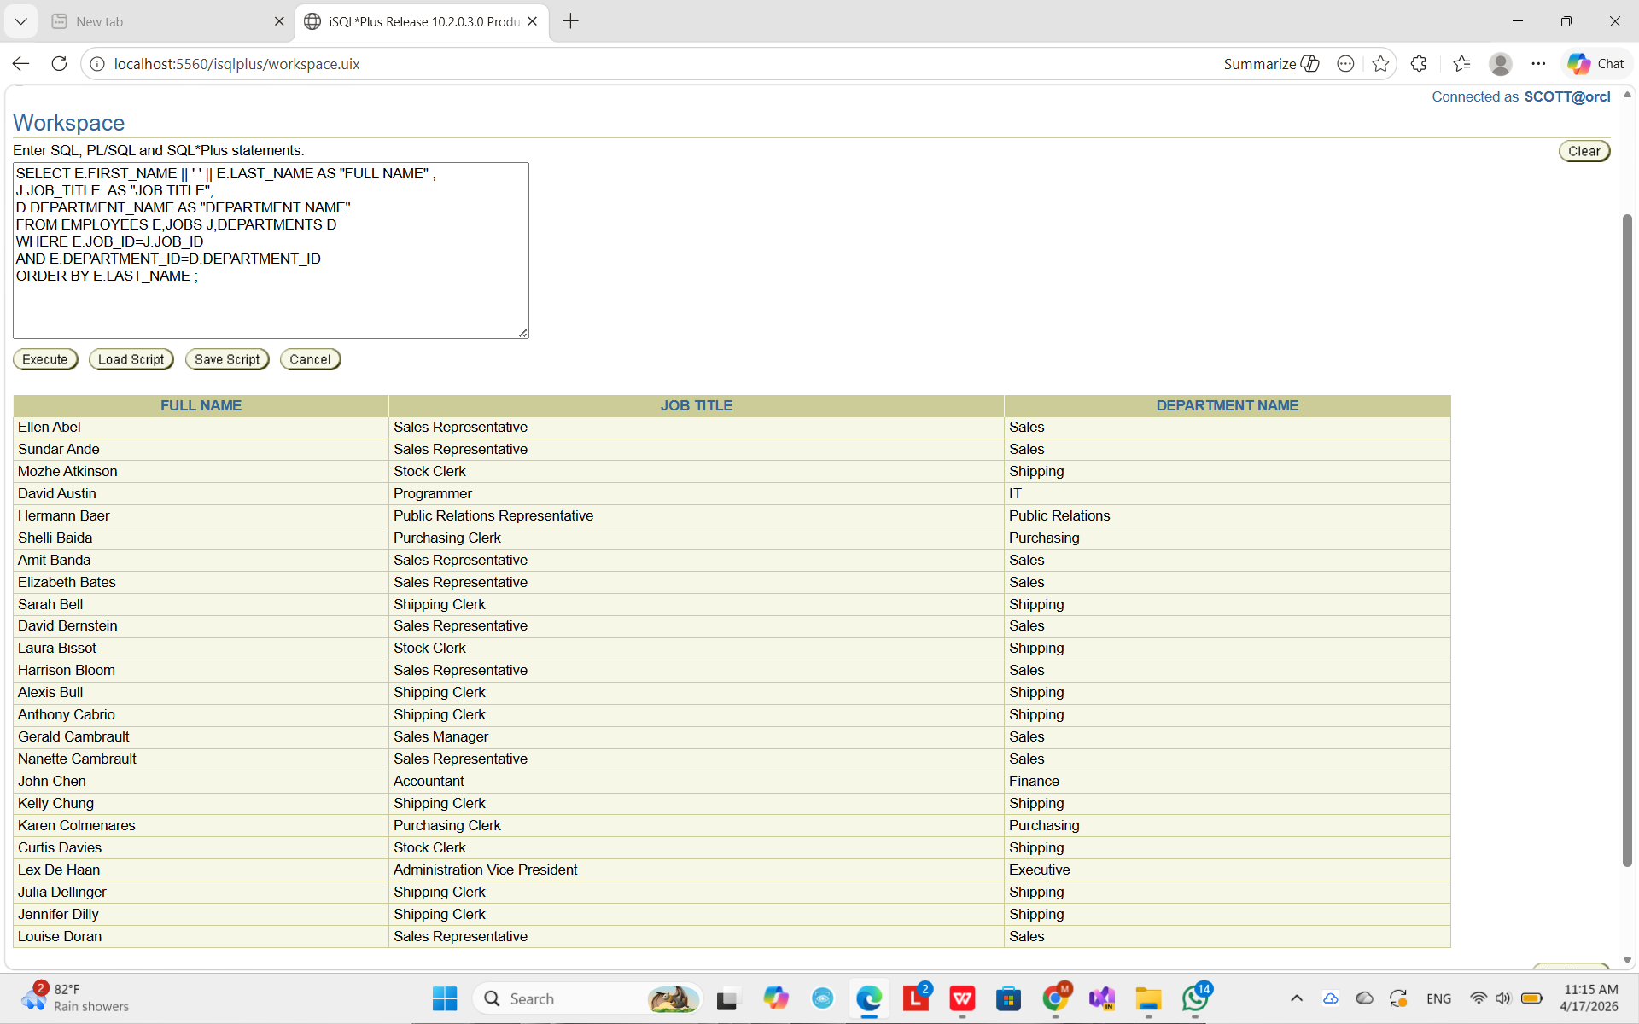

2. Full Details with Email + Location

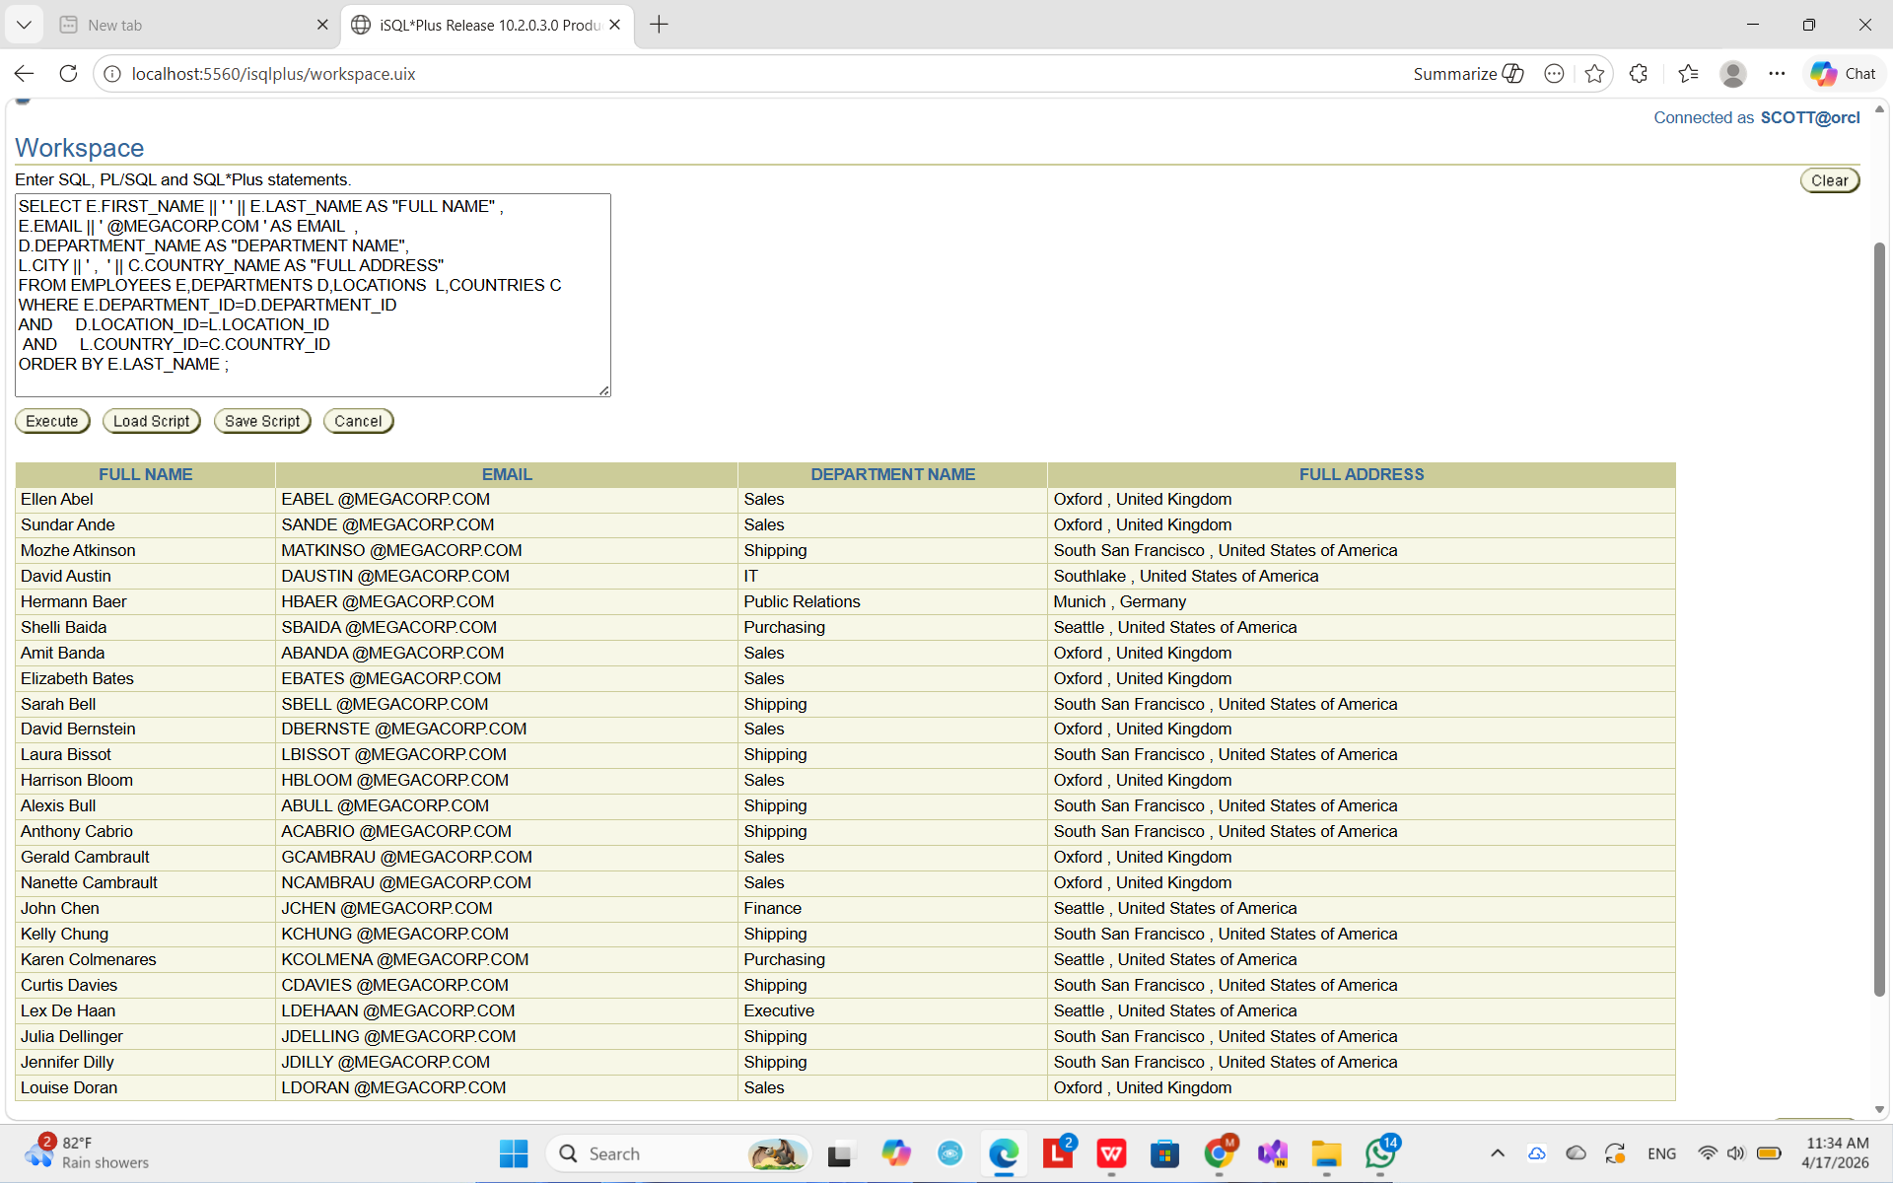

3. Dynamic Country Filter

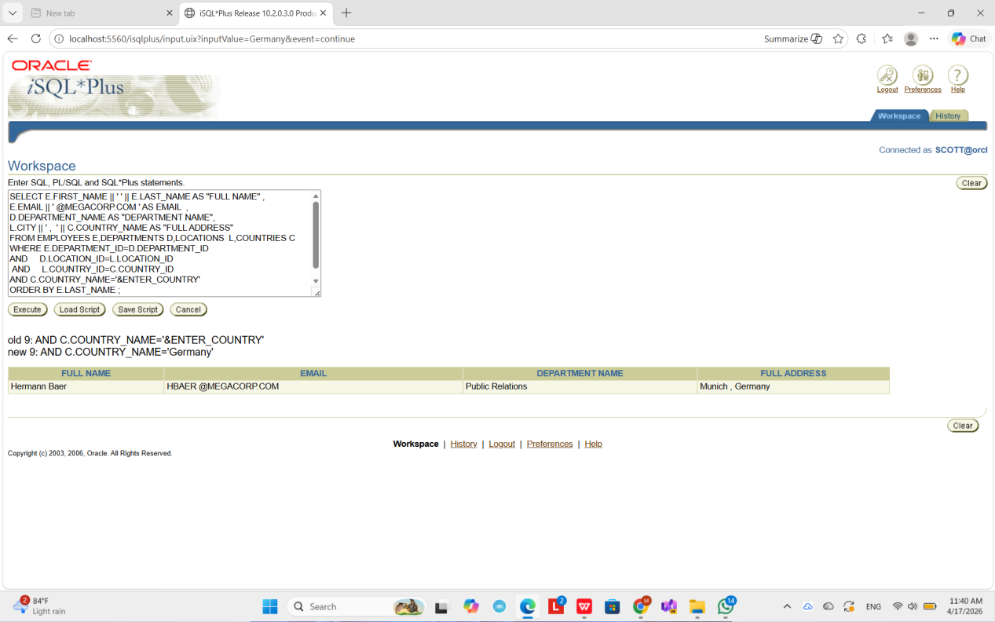

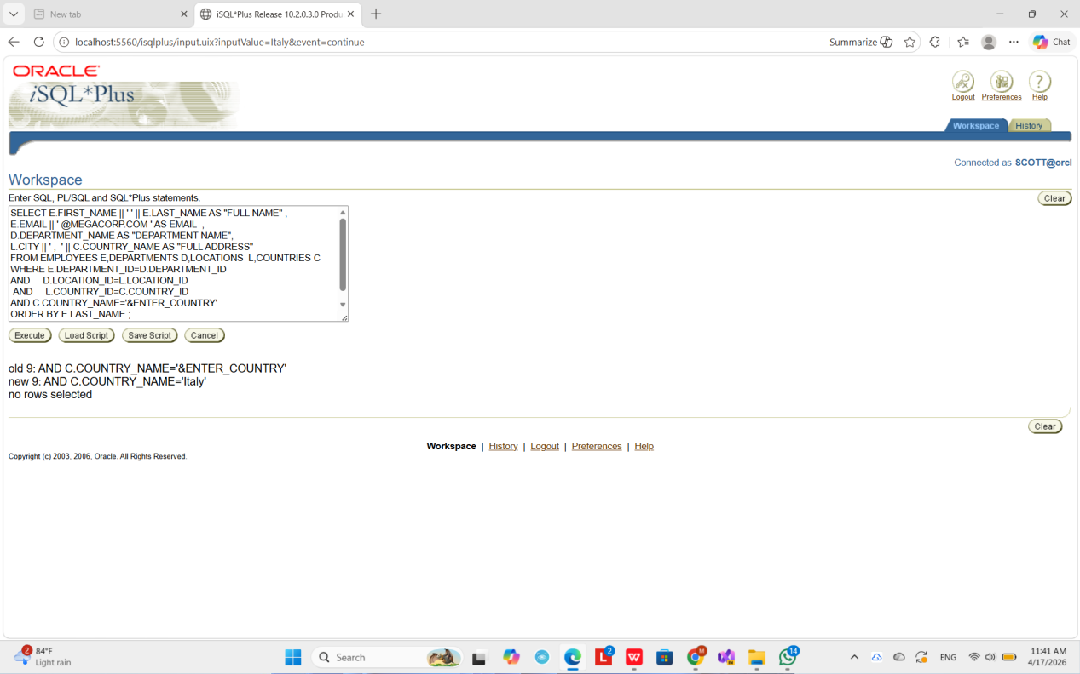

4. All Employees + All Departments

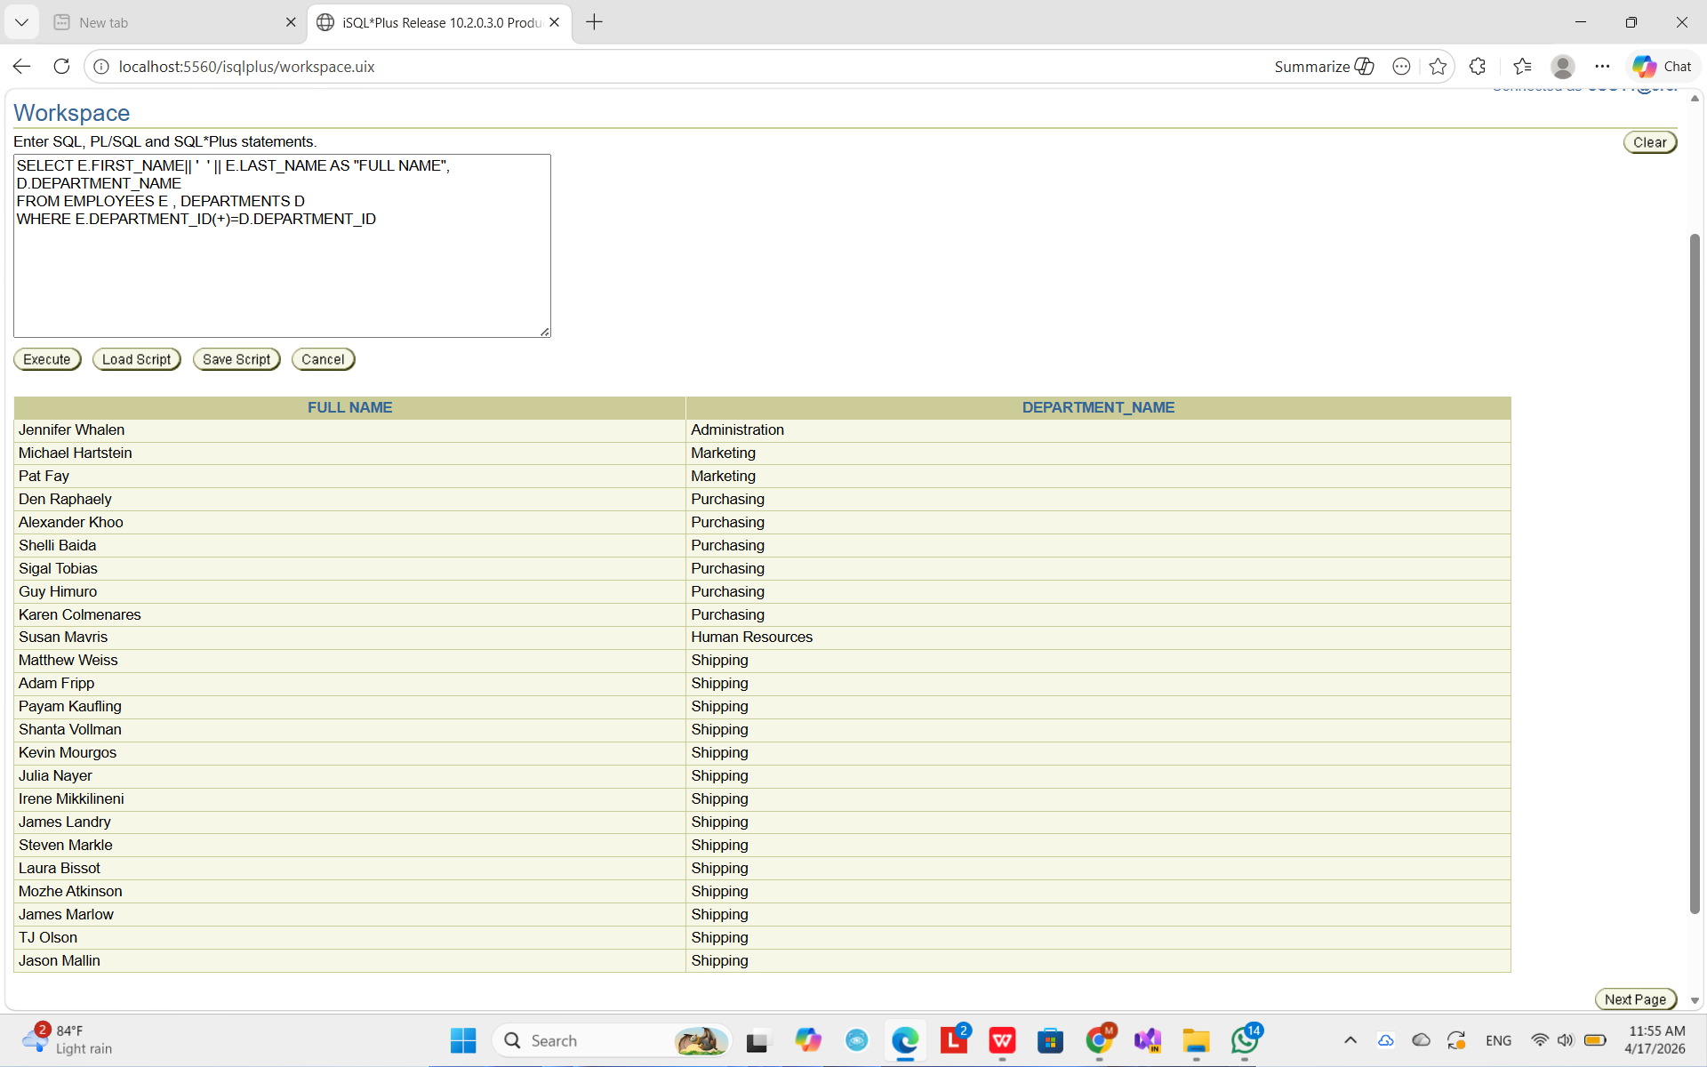

5. Employee + Manager

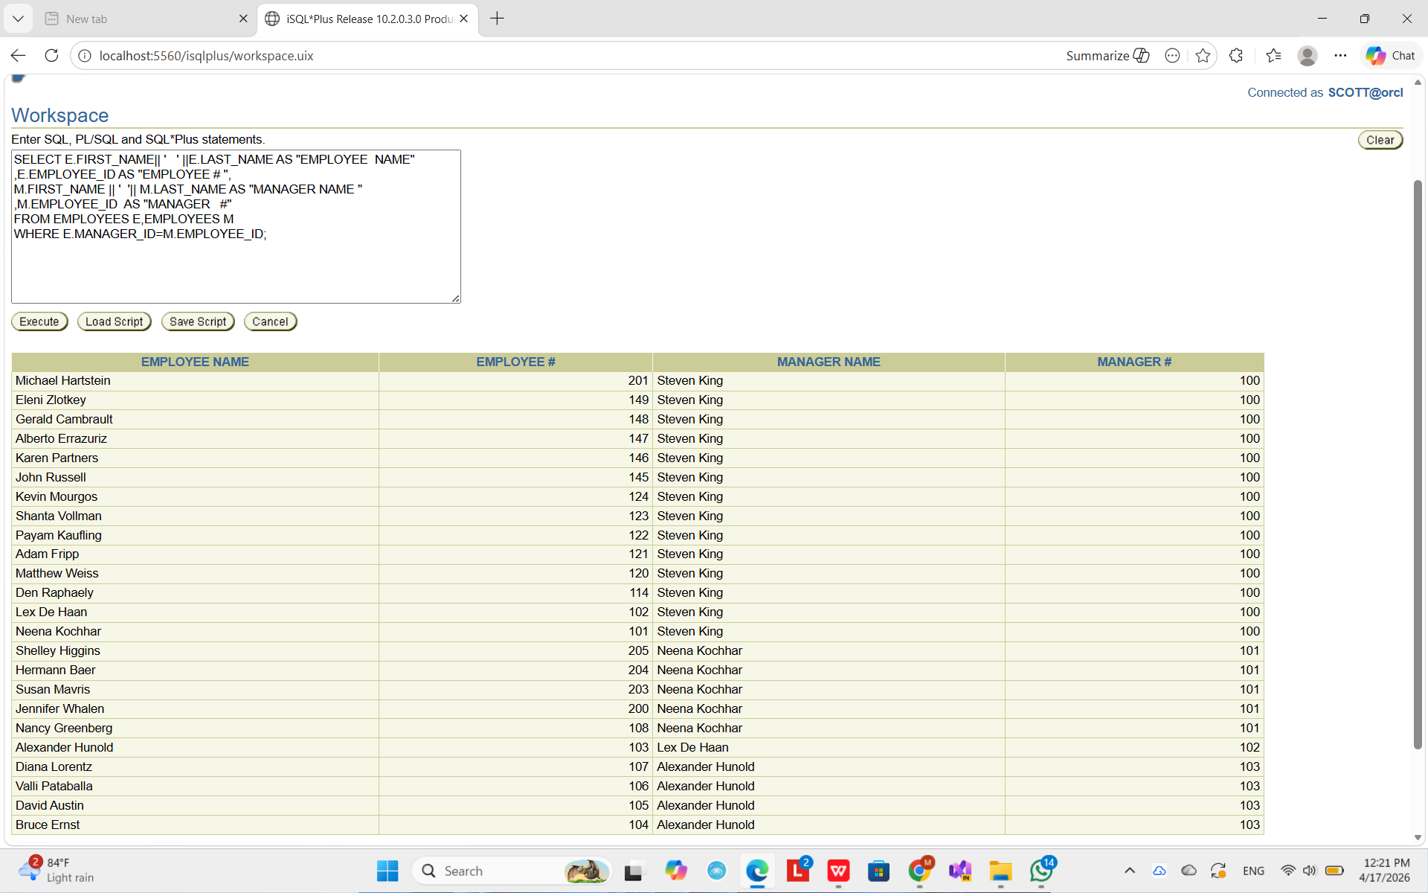

- Why only 106 employees?

This is an INNER JOIN

WHERE E.MANAGER_ID=M.EMPLOYEE_ID;

- Employees with no manager (NULL) are excluded
- That’s why 1 employee is missing → total becomes 106 instead of 107

- Show All 107 Employees

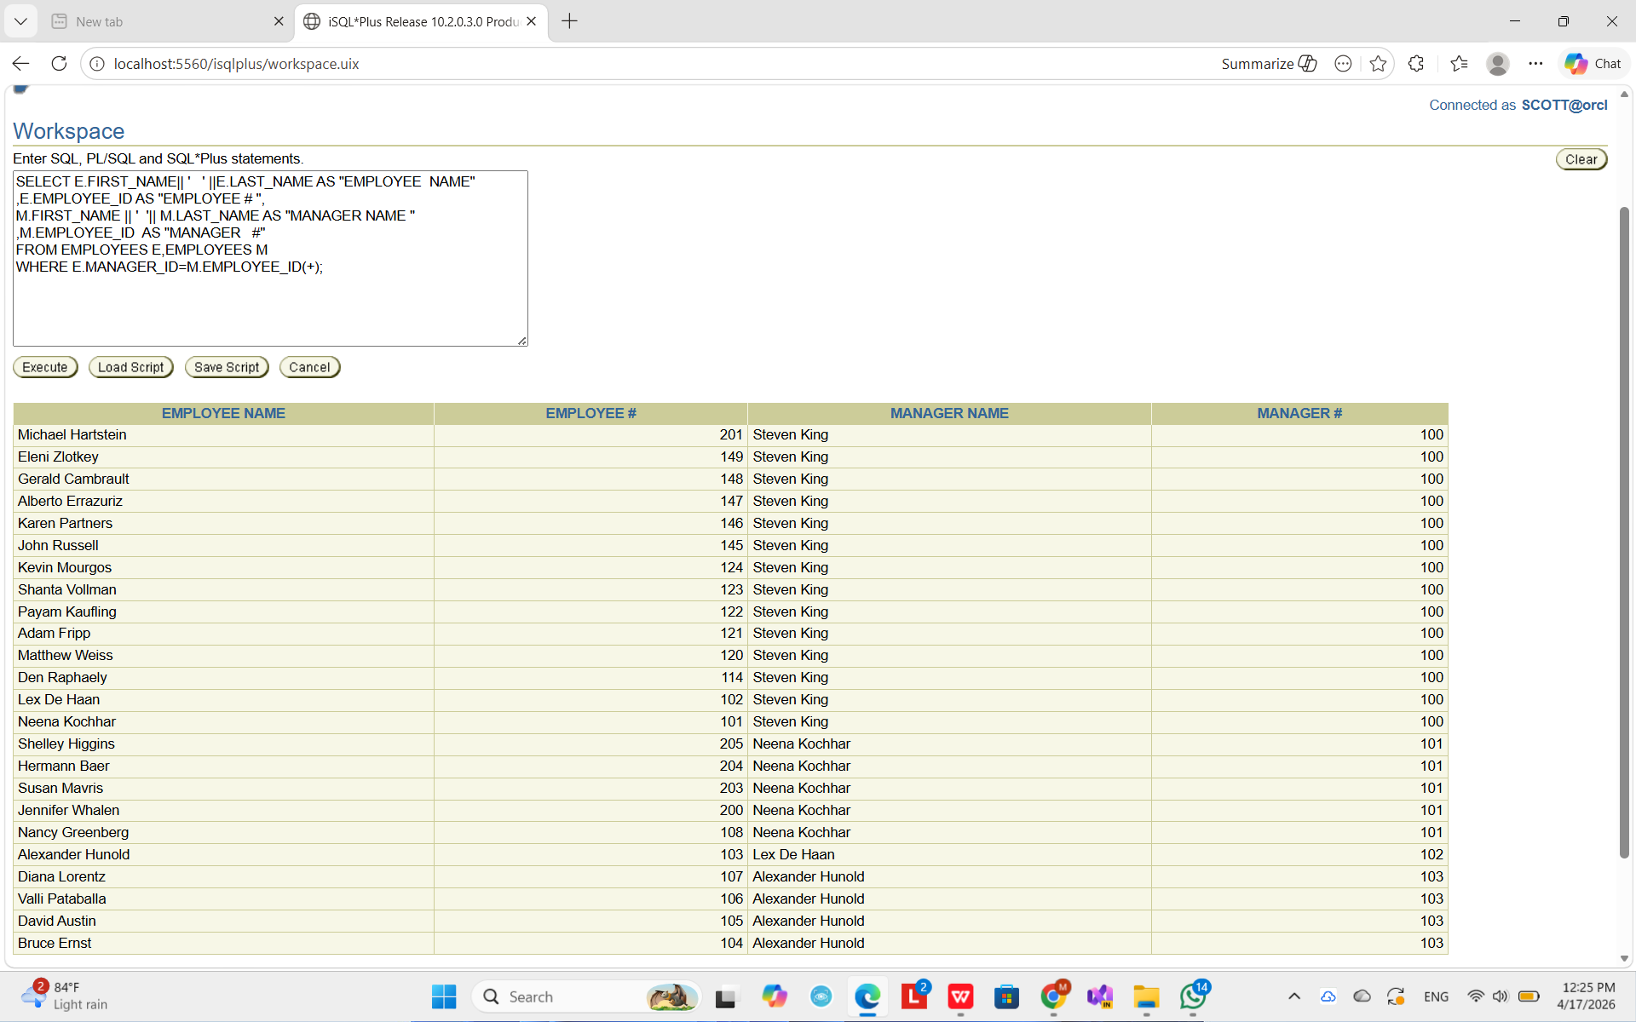

- Salary Greater Than Oliver Tuvault

